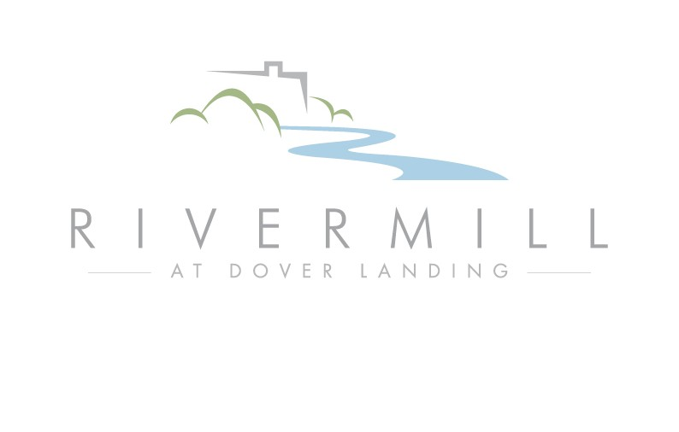

All Inclusive Package
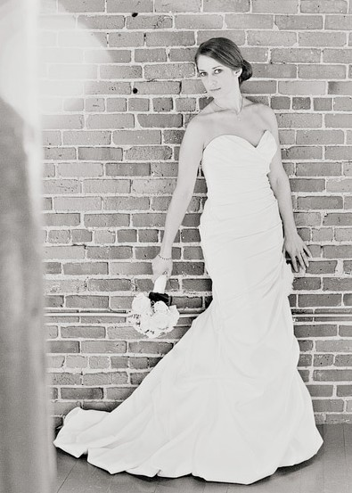
Rivermill at Dover Landing prides itself on offering you the flexibility to
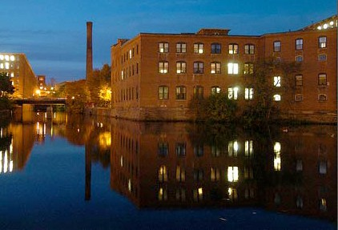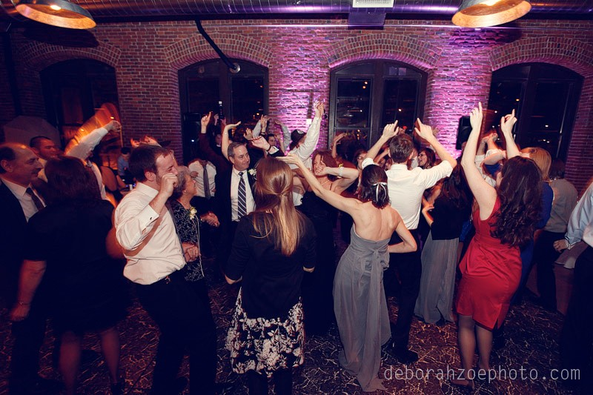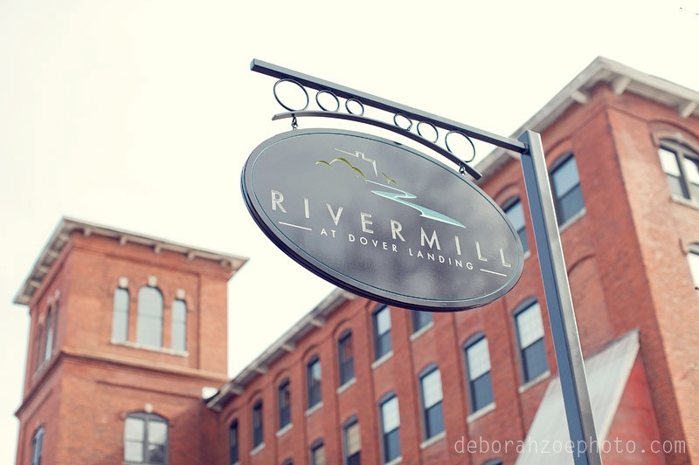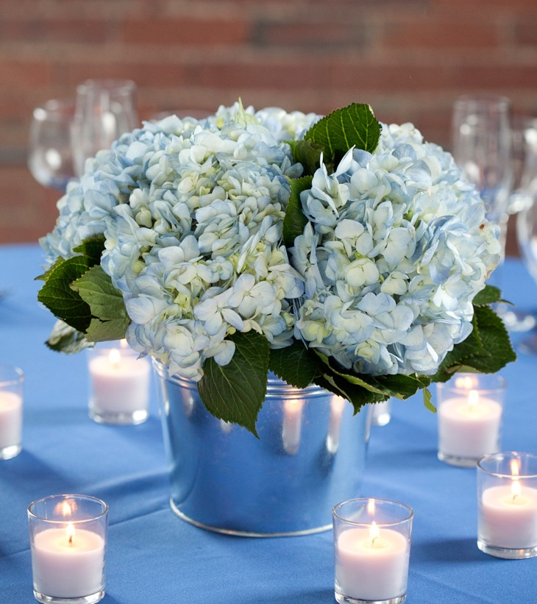make your wedding unique. You are always welcome to use your own vendors, however, we are pleased to present the following All Inclusive Package for the utmost in simplicity as you prepare for your wedding day. This comprehensive package gives you access to some of the top vendors in the area, people we work with all the time. These vendors, combined with Rivermill’s unique setting, are guaranteed to make your wedding memorable and stress-free.

Rivermill’s All Inclusive Package Includes:
- Grand Buffet Dinner by Liberty Lane Catering (Plated option available)
see menu on reverse side
- Reception Floral Package from
Studio Vincca, Drinkwater Flowers or The Flower Room
includes centerpieces, place card table & cocktail tables (based on your choice and Florist’s availability)
- Your choice of DJ Services
DJ Ryan Parker, DJ LoriD, DJ Scott Langlois
(based on your choice and DJ’s availability)
- Custom Wedding Cake from Chickadee Hill Cakes or ConfectionArt

All of the above plus:
- 5 Hours of room use (plus 2 hours of setup)
- Valet parking service
- Your choice of basic linen package
- 60” round banquet tables (comfortably seat 8)
- Padded white garden chairs
- 16x20 dance floor
- Use of Rivermill’s Wedding Party Lounge during your event

$130
per person
May through December
$115
per person January through April

Minimum of 100 guests for package pricing.
Does not include tax and gratuity.
Prices subject to change.

The Rivermill at Dover Landing All Inclusive Package includes a Grand Buffet provided by Liberty Lane Catering, one of our exclusive catering choices.

Plated option is also available for the same price.

Stationary Hors d'Oeuvres
As assortment of imported and domestic cheeses with fresh vegetables and dips, served with gourmet crackers.

Passed Hors d'oeuvres (Choose 3)
- Spanikopita
- Spinach & Goat Cheese Flatbread
- Tomato & Mozzarella Crostini
- Roasted Garlic & Thai Chicken Skewer with Peanut Sauce
- Goat Cheese Mushroom
- Vegetable Spring Roll
- Teriyaki Beef Skewer
- Crab Cake with Basil Aioli
- Vegetable Stuffed Mushroom Florentine
- Red Pepper Hummus Fillo Cup
- Mediterranean Chicken Crostini
- Sausage & Feta Stuffed Mushroom
- Roasted Vegetable Flatbread
- Large Shrimp Cocktail
- Smoked Salmon Mousse in Fillo
- Spinach & Goat Cheese Flatbread
- Antipasto Skewer
- Tomato & Mozzarella Crostini

First Course – Plated Salad (choice of 1)
Crisp lettuce and field greens served with fresh vegetables and Zinfandel vinaigrette with fresh bread and whipped butter.

- or -

Fresh romaine lettuce with toasted croutons, freshly grated Parmesan cheese & classic Caesar dressing

Dinner Buffet
- Sausage & Feta Stuffed Chicken
- Chef Carved Prime Rib
- Pesto Tortellini
- Roasted Red Bliss Potatoes
- Roasted Seasonal Vegetable

Third Course – Plated Wedding Cake

Chickadee Hill Cakes or ConfectionArt

Regular and Decaffeinated coffee station with Assorted Teas

Menu upgrades available for additional charge.
Menu subject to seasonal changes.

Contact us today to learn how we can make your wedding dreams a reality.

